1. Server alive

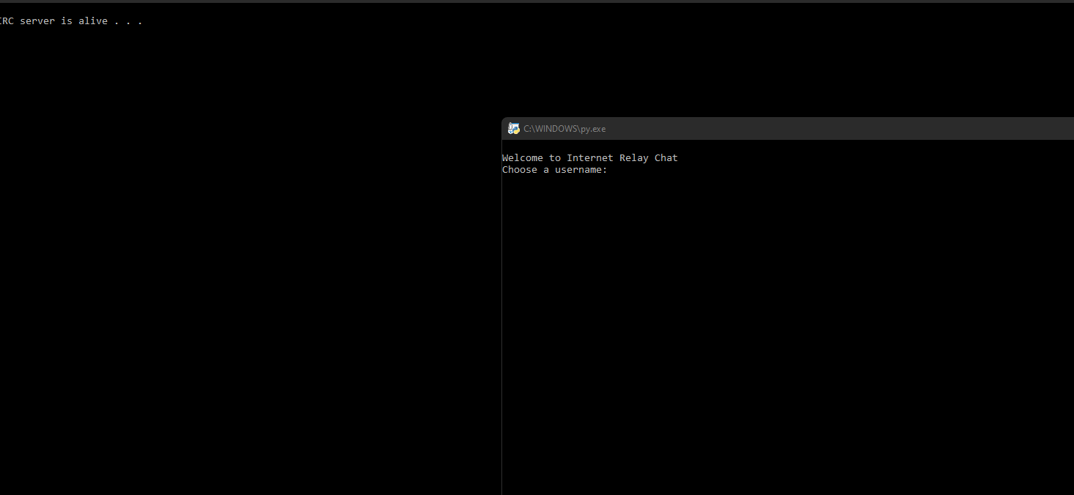

1. List

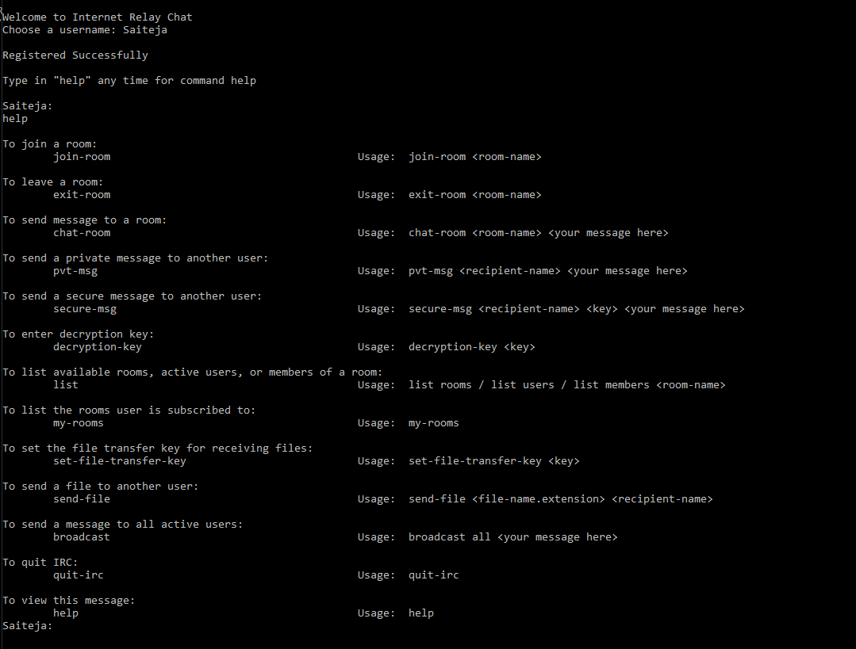

1. Client can create one room

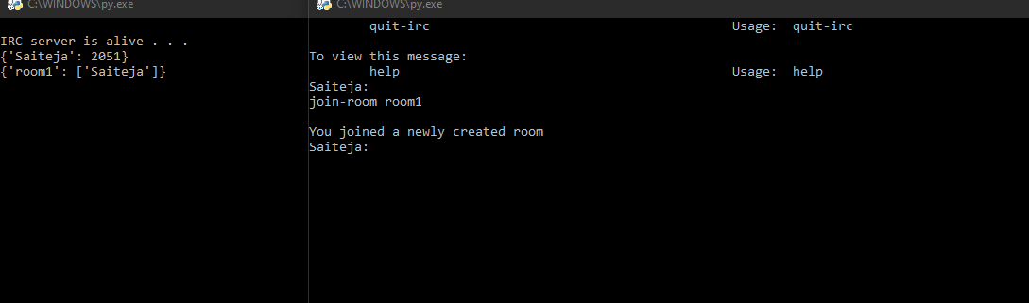

Client can create multiple rooms

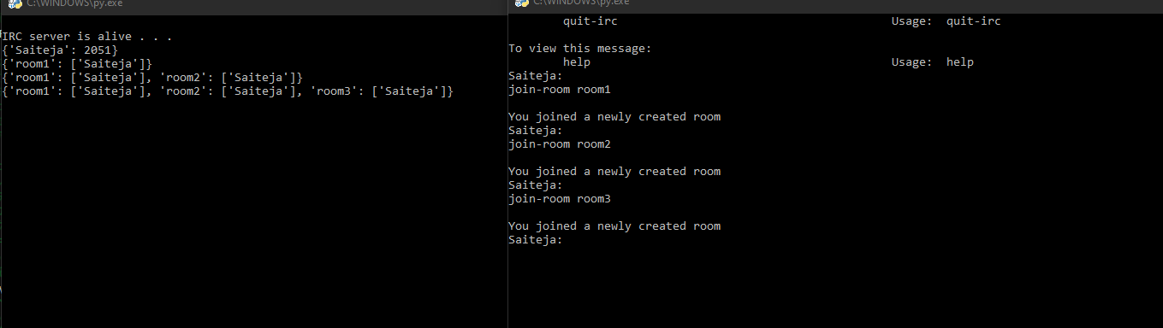

1. List rooms

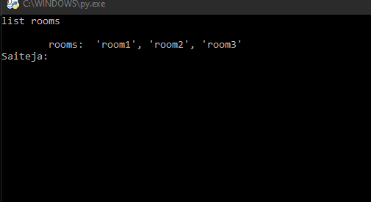

1. Client can list the rooms they joined

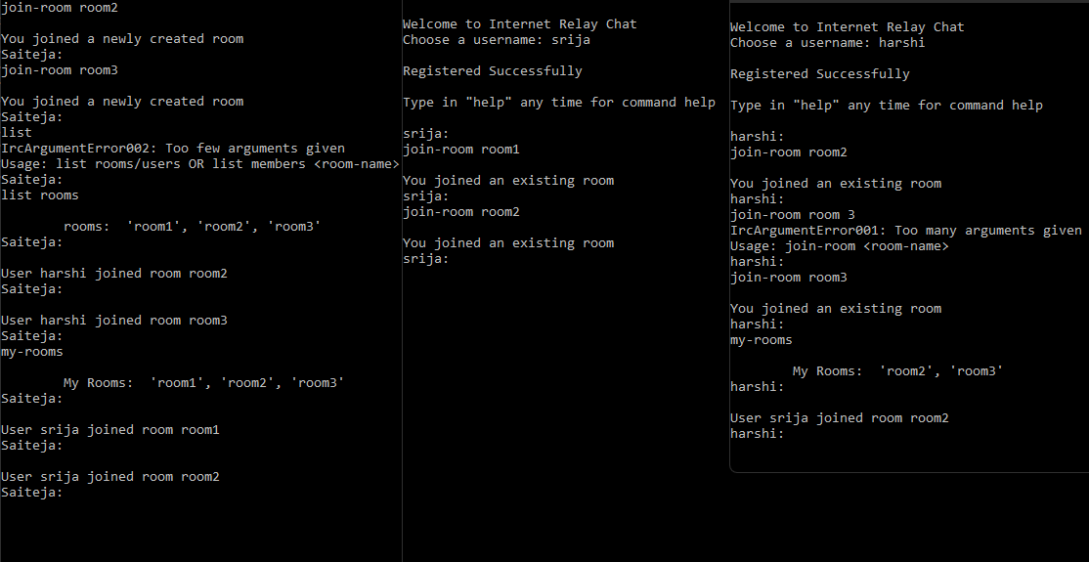

1. Client can leave a room

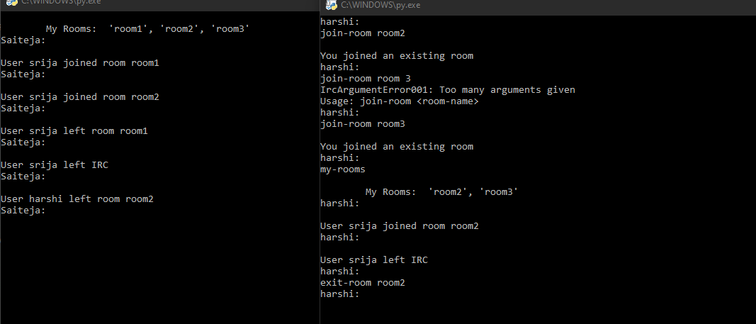

1. Client can list members of a room

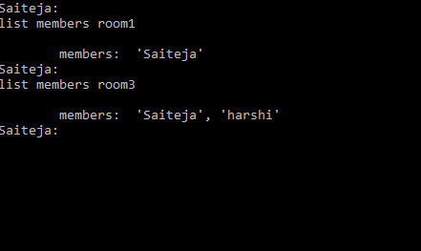

1. Multiple clients can connect to a server

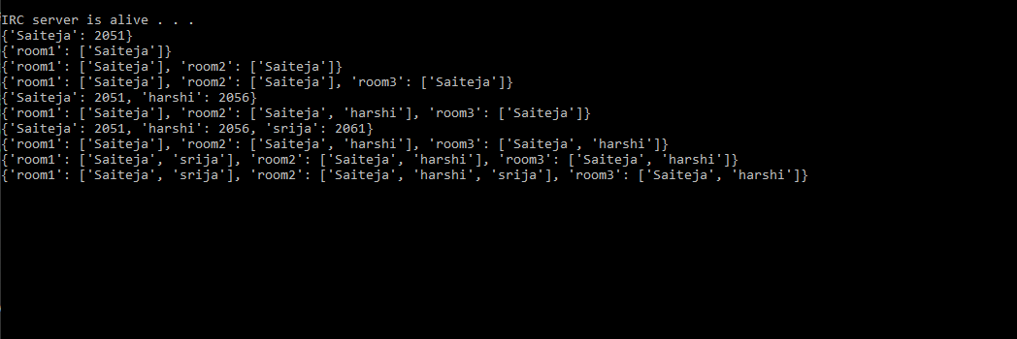

1. Client can send messages to a room

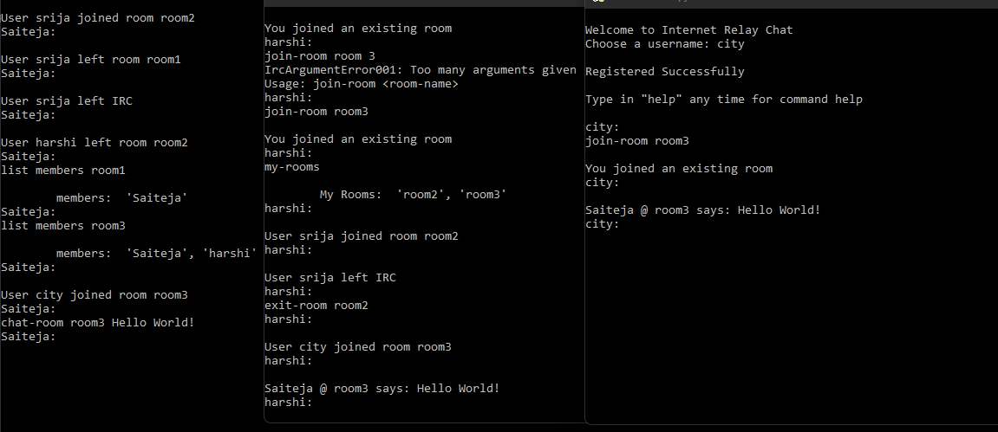

1. Client can join multiple selected rooms

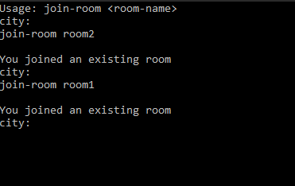

1. Client can disconnect from the server

Quit-irc has been used in user: city, you can view the client disconnecting the server below



1. Server can gracefully handle client clashes

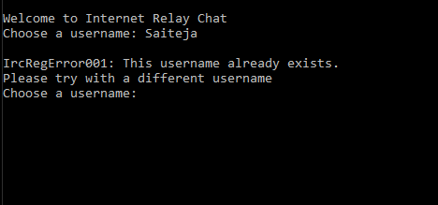

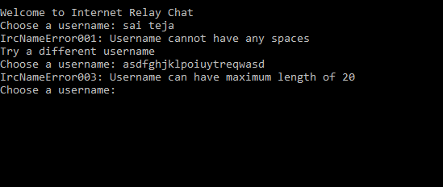

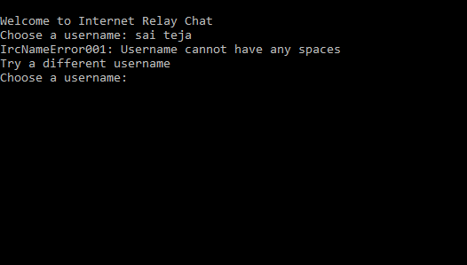

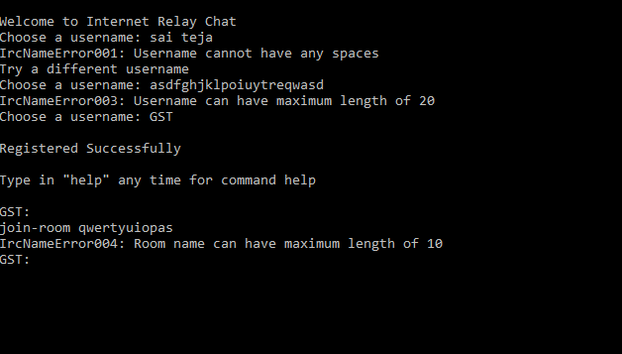

1. Client can gracefully handle server clashes

When server clashes or has some error, if you try to run a command in client, the system will crash making clients to disconnect.

1. Client can send private message



1. Secure messaging

This code is written for Windows OS client and server, and doesn't support secure messaging. Secure messaging is supported only on Linux. To run this code on Linux, un-comment the

commented lines of code. If a Windows specific code line performing the same action is present

in previous line, comment that instead.

1. File-transfer